How to Log EC Ram
A.Use I2EC
1:Run the ITE_WinECU_I2EC
2: set 2E 2F and press set first
3: close program and run the ITE_WinECU_I2EC again.
3:choose the Other => Save All Reg
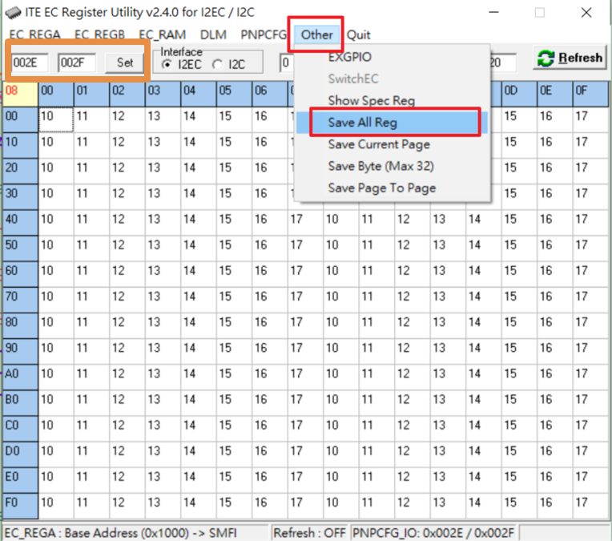
3:The tool will save a AllRegLogYYYYMMDDhhmmss.txt file in same document 

